**Tips to Use Excel to Analyze COMET-Farm Results**

© 2020 American Farmland Trust

**Methods for Building Current Scenarios & Future Scenarios in COMET-Farm & Doing Analysis in Excel**

Given AFT interviewed "soil health successful farmers” and we want to know what the climate benefits are of that investment in soil health, AFT used COMET-Farm differently than the standard “what if” scenario tool it was built to be. We did not ask, “What if the farmer adopts a new practice in the future?” Nor did we ask, “What if the farmer continues adoption of his/her existing suite of soil health practices?”

Instead, we asked, **“What is the percent reduction in climate emissions from this X-acre field attributable to the soil health practices?”** To estimate that, we proceeded with data entry into COMET-Farm Tool’s Current management Scenario as usual but then created a dummy Future Scenario in order to export the current emissions data into excel where we compared the average total GHG emissions over the soil health time period to the average emissions from the “before soil health” time period.

Before using these instructions to conduct similar analysis, you should reach out to Dr Mark Easter of Colorado State University (CSU) who is the lead developer for COMET-Farm to request some technical assistance using the tool in this manner. Dr. Easter or his designate will review your project objectives and the specific details of the farmer you are analyzing to ensure use of this excel-based approach and above research question is appropriate for your analysis. If not, ask for guidance on how to do data entry with the goal of using the graphical user interface (GUI) results table in COMET to read off your results.

**Overview of how to implement the aft-approach to a comet-farm analysis (followed by a step-by-step set of instructions):**

1. Input the data you obtained from the NTT/COMET interview from your excel-based Questionnaire into the Current Management Scenario section of COMET-Farm tool.
2. Create a default Future Scenario, just so you can produce the graphical user interface (GUI) results table in order to export the data to excel. You will not use information in the GUI table.
3. From the GUI, export the data to excel.
4. Analyze the data in excel. See the individualized recommendations (in green) starting at page 6 of this document from Matt Stermer, COMET Outreach Specialist for Colorado State University (CSU) for how many and which years should represent the “before” and “after” soil health years you will analyze for each farmer.
5. Write the first key publishable COMET sentence:

*USDA’s COMET-Farm tool estimates that Farmer Name’s soil health practices resulted in a X% reduction in total greenhouse gas emissions from the Y-acre focus field.*

1. Return to the GUI page of COMET-Farm and click on EPA GHG Equivalency Calculator (<https://www.epa.gov/energy/greenhouse-gas-equivalencies-calculator>) to write the second key publishable sentence.

*This corresponds to taking Z number of cars off the road.*

1. AFT authors sent both sentences to Stermer, including their excel file, their username and password, and name of the project so he could review their data entry and check and approve their analysis. The authors then sent Stermer’s approval email to the Project Leader for the sake of due diligence.

**STEP-BY-STEP INSTRUCTIONS TO SET UP A DEFAULT FUTURE SCENARIO IN ORDER TO EXPORT COMET-FARM RESULTS TO EXCEL FOR ANALYSIS VIA THE AFT APPROACH**

**Note**: You will need to build a future scenario (though you will not end up using it) in order for the model runs to complete. This, in turn, will allow you to export the data into excel. Follow these instructions to build a default future scenario (which essentially copies the baseline data inputted into the Current Scenario from 2009 and pastes it into 2019; copies 2010 and pastes it into 2020 and so on).

1. When you’ve finished entering the farmer data from your excel-based NTT/COMET interview questionnaire into the Current Management section of the tool, this screen will pop up and you should click on Continue to Future Management (see screen shot below).

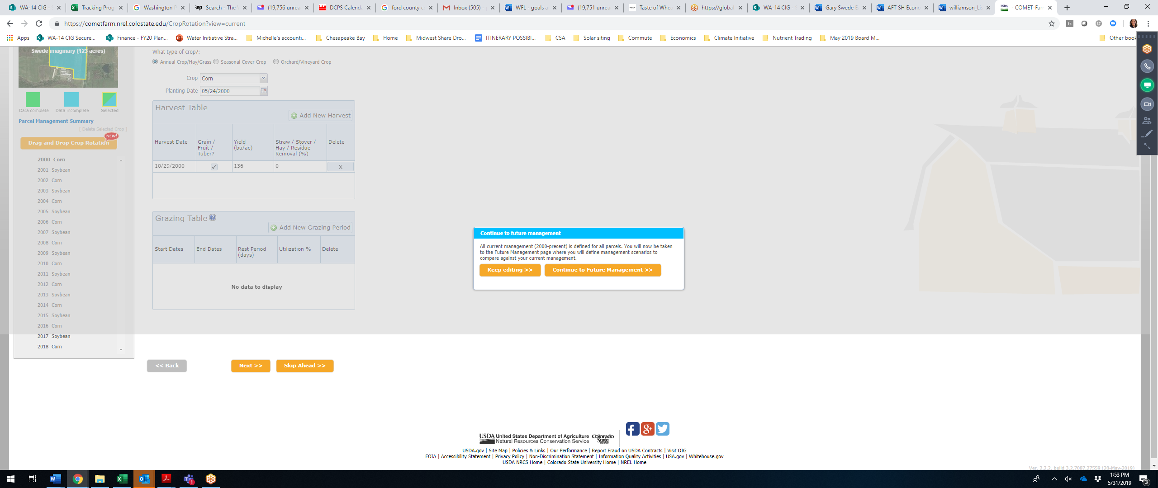

1. Enter a name for your first management scenario (call it “Default Future Scenario”)
2. Click on “Copy management information from my Current Management”
3. Click on Start

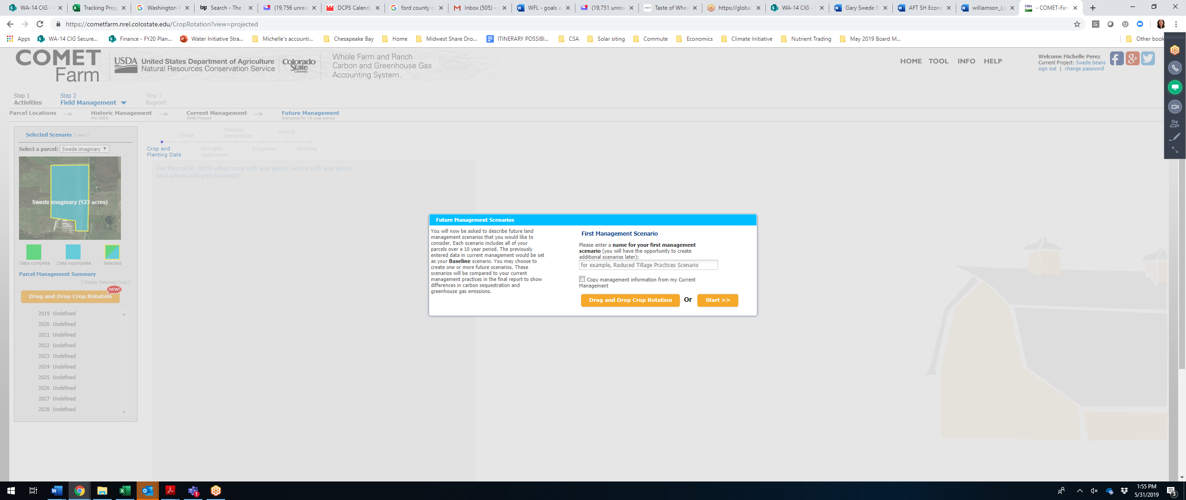

1. If you are exporting to excel, you are done. Click on skip ahead.
2. When asked to add an additional crop, click on “No Thanks, Continue”

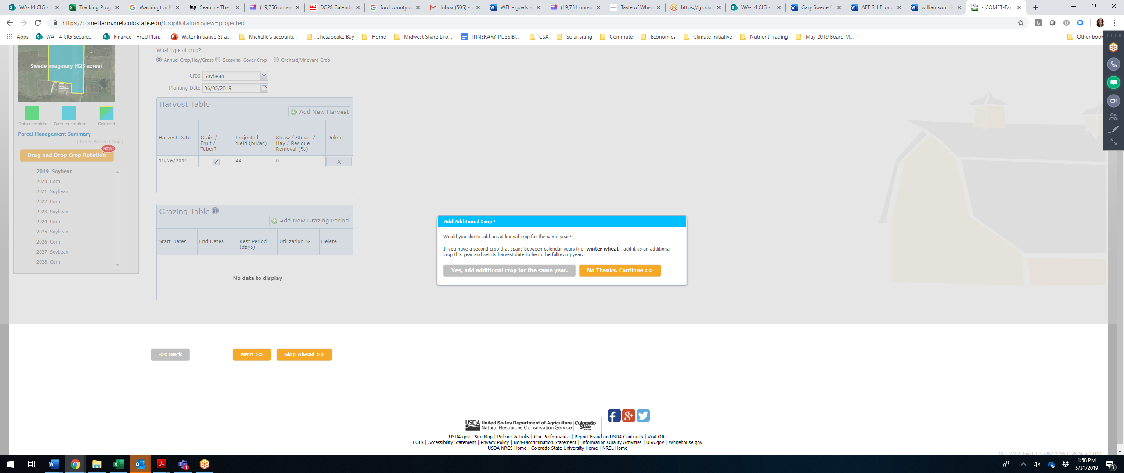

8. When asked to Copy the Crop, click on “No Thanks”

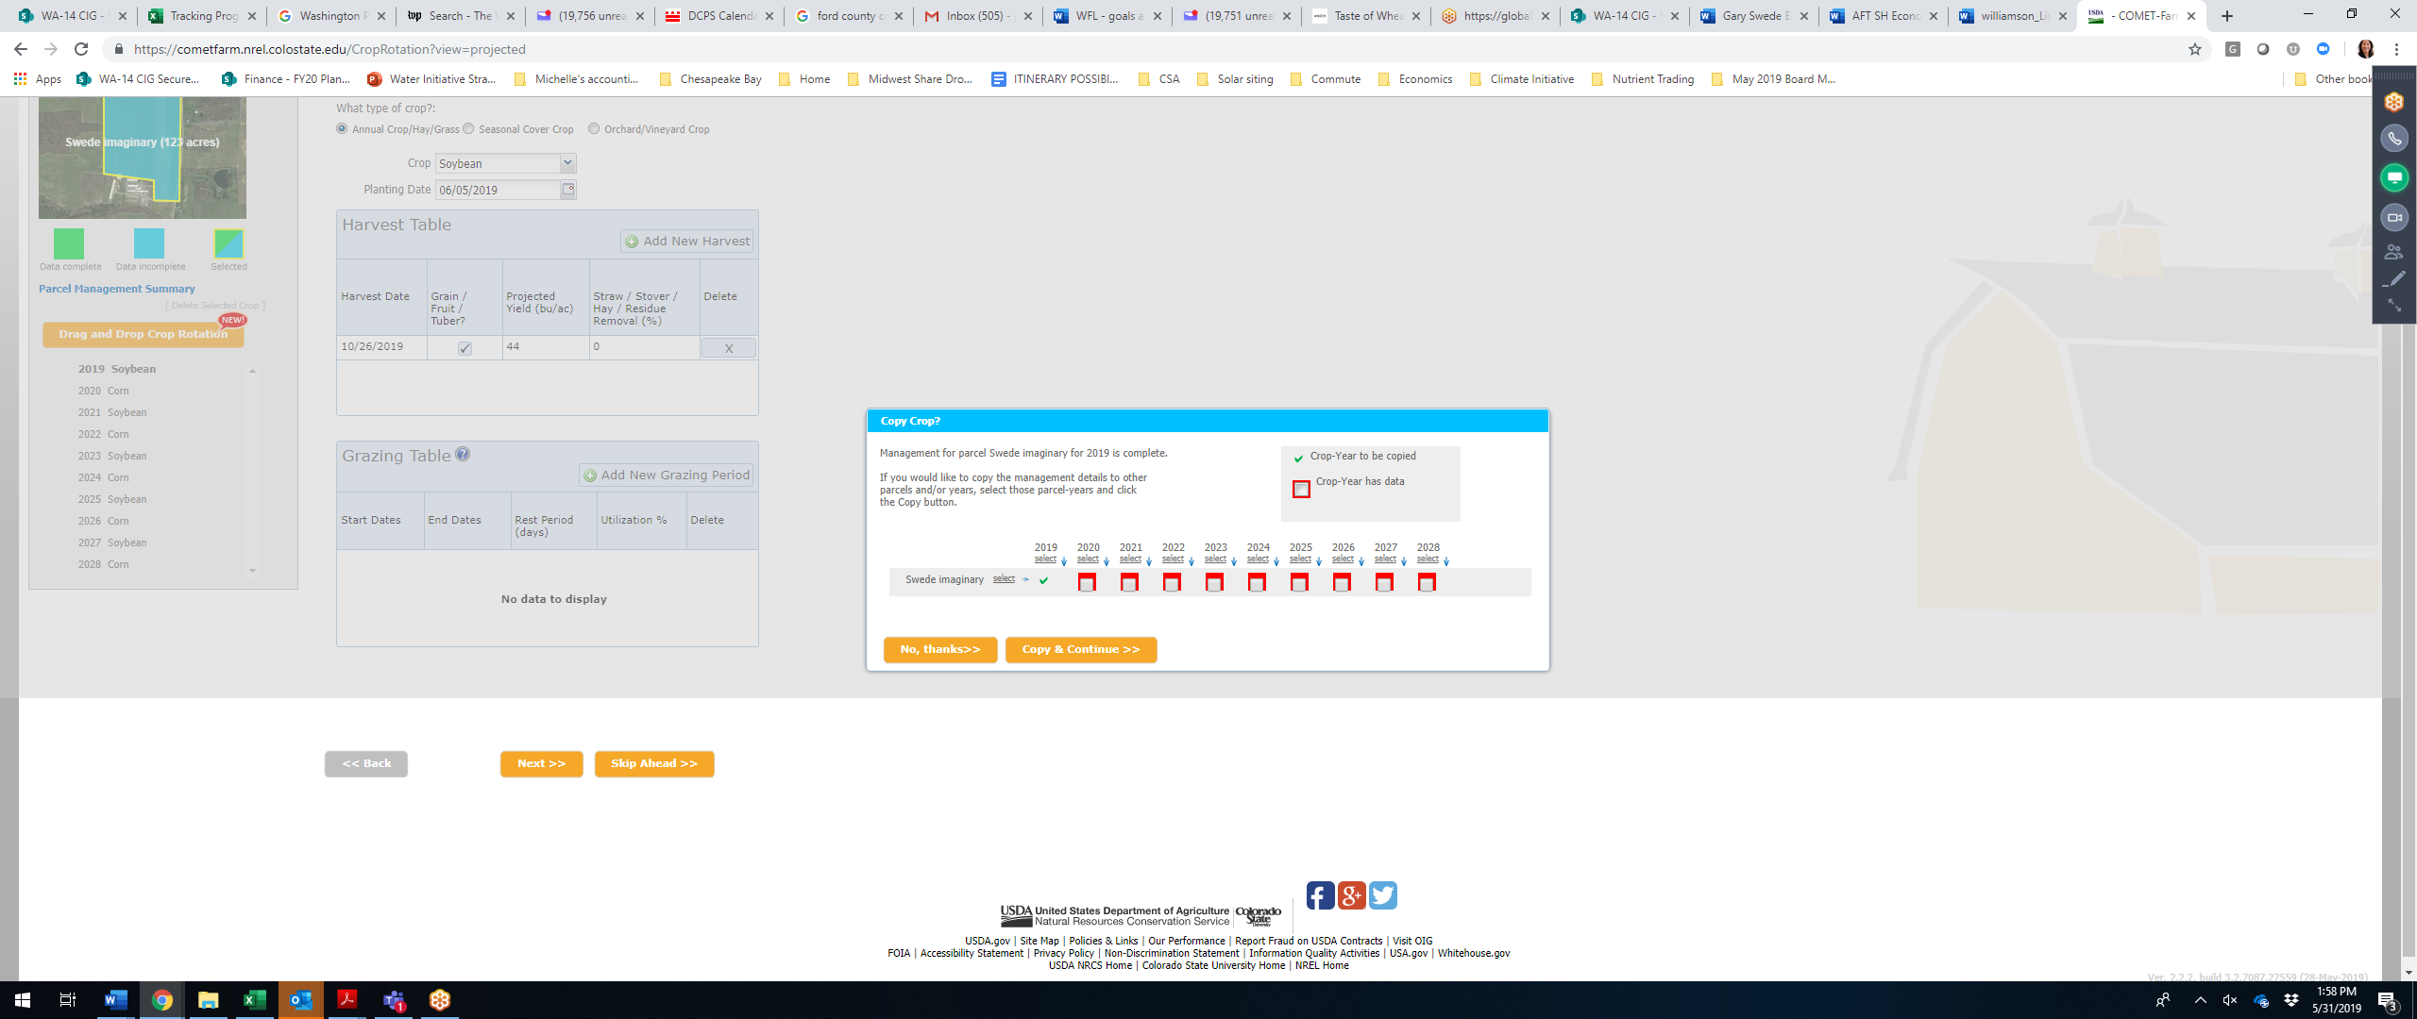

9. When asked to run the report, click “Continue to Report”

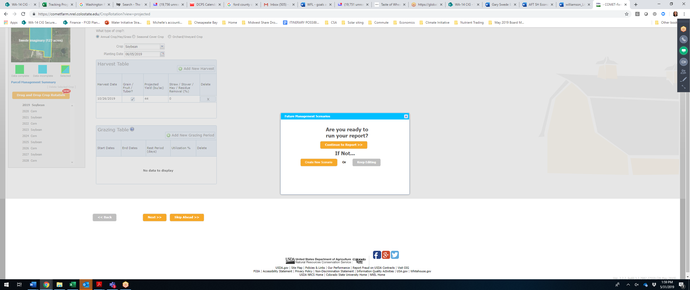

**STEPS TO EXPORT DATA TO EXCEL:**

1. Now that you’re looking at the GUI (graphical user interface) results table, click on the button at the bottom of the page that says “Export Crop Management Data”
2. Click on “Export Annual Outputs in Columns” button
3. Once you’re in excel, you will only be using the Current Scenario information so please disregard all the rows labeled “Future” scenario.

**ANALYZING DATA IN EXCEL:**

**Note**: See the excel file, **“Example COMET File to Analyze Results in Excel”** for the tutorial on estimating the change in total GHG emissions between the “soil health years” and the “before soil health years.”

1. Scroll down to the rows labeled in column A as “Current. This is the Current scenario reflecting all the data you obtained from the interview and inputted into the tool.
2. Scroll to the right to column AK.
3. Take the average total GHG emissions of your “before soil health years” – See examples from AFT Authors, Brandt and Bruner, and recommended set of before soil health years from Matt Stermer on page 7.
4. Take the average total GHG emissions for your “after soil health years” – See examples from AFT Authors, Brandt and Bruner, and recommended set of after soil health years from Matt Stermer on page 7.
5. Get the percent change in emissions between the after soil health years (new value) and the before soil health years (old value) using the formula: (New value – Old value) / Old value * 100.
6. Add the sentence about how many cars are taken off the road. See instructions for “Obtaining the Car Statistic” below.
7. Write out your sentence using only the percent reduction in GHG value (i.e., do not give the actual GHG emissions values).

*AFT used USDA’s Nutrient Tracking Tool to evaluate First Name’s use of X, Y, and Z practices on a X-acre field and found that they reduced his nitrogen, phosphorus, and sediment losses by X, Y, and Z% respectively. USDA’s COMET-Farm tool estimates that Farmer Name’s soil health practices resulted in a X% reduction in total greenhouse gas emissions from this same field. This corresponds to taking X number of cars off the road.*

1. Share both sentences with Matt, including your excel file, user name and password, and name of the project so he can review and approve. Save his email approving your work to your Sharepoint folder.

**OBTAINING THE CARS STATISTIC**

Note: We would like to give readers context for how much total GHG reduction the farmer’s focus field is offering by using the EPA’s GHG Equivalencies Calculator (<https://www.epa.gov/energy/greenhouse-gas-equivalencies-calculator>).

**Excel users:**

1. In your excel file, take the “new minus old” value (e.g., -14.12 total GHG emissions reduced in the “Example COMET File” doc) which represents the change in emissions between the “soil health years” and the “before soil health years” and is the net reduction in total GHGs emissions (tons CO2-equiv) due to the soil health practices, and insert it into the EPA Calculator.
2. You’ll find a blue link to the calculator at the bottom of the GUI reports page: the EPA’s GHG Equivalencies Calculator or go directly to it using the link above.
3. Once on the EPA Calculator website, scroll down and click on the tab “If you have Emissions Data.” Insert your net reduction in CO2-eqivalent tons in the first row labeled "metric tons of CO2-eq" to find out how many passenger vehicles or number of miles driver per year that amounts to.
4. Insert the number of passenger vehicles into the template sentence in blue font above.

*Example: If your “new minus old” value was -14.12, then your SH practices resulted in a net reduction of 13 CO2-equiv tons of GHG emissions. Insert “14” into the EPA Calculator, and it says, that is the equivalent of 3.1 passenger vehicles driven for one year or 35,037 miles driven per year. Thus, you can say, the soil health practices on this x-acre field is equivalent to taking 3 cars off the road.*

**GUI users:**

1. Go ahead and use the negative green value (hopefully!) in the Change column within the Future Scenario Section to insert into the EPA calculator
2. At the bottom of the GUI reports page, use the EPA’s GHG Equivalencies Calculator (see blue link) to insert your net reduction in CO2-eqivalent tons to find out how many passenger vehicles and miles driven that amounts to.

**Key Tips to Share:**

1. **DOING THE MATH IN EXCEL** - In the Exported Excel results table, you must compare the same number of years to the same number of years. And ideally, that number of years is 10 (though one non-government organization went as low as 3 years, a few of our farmers are going as low as 4 years).
2. **TIPS FOR BUILDING REAL FUTURE MANAGEMENT SCENARIOS –** If you decide not to use the option to export the COMET Current Scenarios into Excel for that interpretation technique but instead want to want to interpret the GUI results table in COMET-Farm (a.k.a. the GUI or the Graphical User Interface), you need to build real future management scenarios rather than fake ones.
   1. In the Future Management Scenario section of COMET, the tool will, by default, make 2019 data reflect the data from year 2009 and so on (2020 data will, by default, reflect 2010 data). See tips to create the default Future scenario.
   2. Ideally, the 2009 crop being grown is the right one to appear in 2019. For example, if it was corn in 2009 and soybeans in 2010, then hopefully it’s corn in 2019 and soybeans in 2020 and the corn-soybean rotation every year is maintained.
   3. You want to force 2019 to reflect year 2009, even if that’s not when the farmer’s soil health journey started. Also, ensure that, if you have a corn-soybean rotation, you maintain that order of the rotation. It is critical to compare the same crop in the rotation in the Current Scenarios to the same crop in the Future Scenarios.
3. **GUI RESULTS TABLE INTERPRETATION** – If you developed real future management scenarios and want to interpret the GUI results table, the column of data labeled, “Baseline Emissions,” shows the emissions for the last 10 years only, i.e., 2009 to 2018 (even though data input is required for 2000 to 2018).
   1. Negative black values are good and indicate reductions in emissions.
   2. Negative green values are good and show the comparisons between baseline and future scenarios indicating an increase in carbon (C) sequestration or an increase in emissions reductions.
   3. Positive black values are bad as they indicate a loss of C or an increase in emissions.
   4. Positive red values are bad and show the comparison between baseline and future scenarios and indicate a loss of C or increase emission.

**TIPS ON SELECTING THE # OF YEARS OF SOIL HEALTH PRACTICE ADOPTION FOR ANALYSIS IN EXCEL**

**Examples from the farmers interviewed by AFT authors Brandt & Bruner & CSU’s Matt Stermer’s recommendations**

**BRIAN BRANDT, OH – corn soybeans**

Eric Niemeyer – Corn/Soybean

* No-till – 2011
* Nutrient Management – 2011
* Cover crops – 2014
* Matt Stermer recommends:
  + Future scenario – Simply create the default future scenario in order to get to the GUI results table and click on the “Export Crop Management Data” button.
  + In the excel file, only use the Current Baseline section of data to average the GHG emissions from **2003 to 2010 (8 years) and compare that to the average GHG emissions from 2011 to 2018 time period (8 years).**
  + It’s okay if 2003 was corn and 2011 was soybeans. Hopefully there isn’t a big change in crop rotation. If there was a big change in crop rotation, let’s revisit.

Dan Lane – Corn/Soybean

* No-till – 2010
* Nutrient Management – 2012
* Matt Stermer recommends:
  + Future scenario – Simply create the default future scenario in order to get to the GUI results table and click on the “Export Crop Management Data” button.
  + In the excel file, only use the Current Baseline section of data to average the GHG emissions from **2001 to 2009 (9 years) and compare that to the average GHG emissions from 2010 to 2018 time period (9 years).**

**EMILY BRUNER, IL VH – corn-soybeans**

Thorndyke – 2 yr rotation – corn, soy

* + - No-till beans, strip-till corn – 2014
    - Cover crops – 2014
    - Nutrient management – 2015 (cut P and K in half, moved to all spring N application)
* Matt Stermer recommends:
  + Future scenario – Simply create the default future scenario in order to get to the GUI results table and click on the “Export Crop Management Data” button.
  + In the excel file, only use the Current Baseline section of data to average the GHG emissions from **2009 to 2013 (5 years) and compare that to the average GHG emissions from 2014 to 2018 time period (5 years).**

Ifft – 2 yr rotation – corn, soy

* + - Cover crops – 2015
    - Nutrient Management – 2018 (split 3-way spring N application)

🡪Matt Stermer recommends:

* + Future scenario – Simply create the default future scenario in order to get to the GUI results table and click on the “Export Crop Management Data” button.
  + In the excel file, only use the Current Baseline section of data to average the GHG emissions from **2011 to 2014 (4 years) and compare that to the average GHG emissions from 2015 to 2018 time period (4 years).**