**Transfer Tools Information Sheet**

There are four main ways to transfer assets like land and buildings, the farm/ranch business, and personal property like cash, investments, or family heirlooms. They include gifts, sales, inheritance, and leases which can be used separately or combined in various ways.

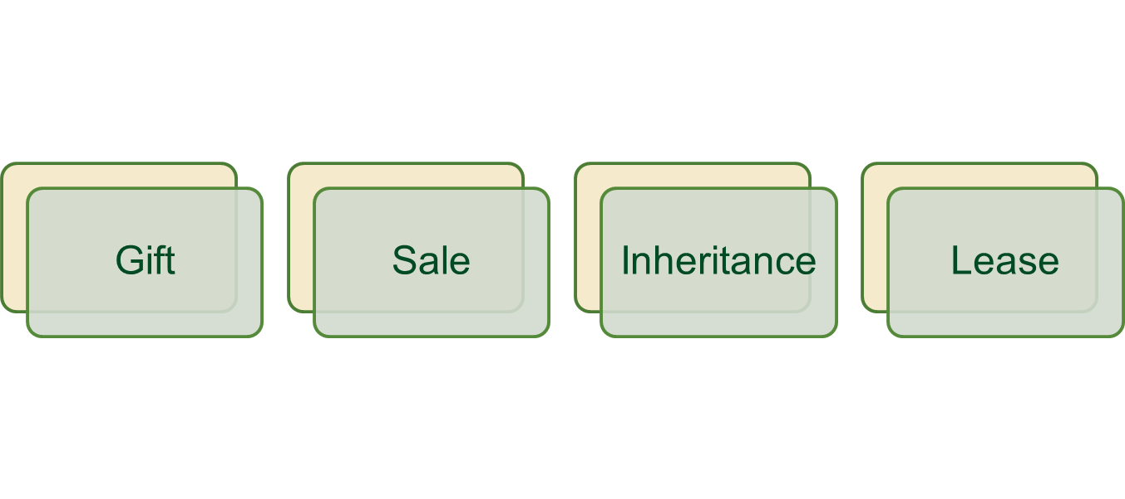

**Gift:** A gift is a transfer of an asset where the giver receives no payment, or less than full market value payment, in return. Gifts can be full or partial.​ They can include any kind of asset from land to the business to personal assets.​ They also are a way for owners to reduce the value of their estate to lessen the tax burden on their heirs. ​A “bargain sale” (see below) is part sale, part gift.

​**Sale:** A sale is a transaction between two or more parties where the buyer pays the seller to receive assets, goods, and/or services. Sales can be partial or discounted, made in installments, or transferred gradually over time, and can include everything from land to equipment to the entire farm or ranch business. ​A *“bargain sale”* is a discounted sale where land or other appreciated property is sold at less than its fair market value. It generally is used for a sale to a land trust or other nonprofit organization and combines the benefit of receiving payment from a sale with the benefit of tax reduction from a charitable donation. ​

​**Inheritance**: Inheritance occurs when assets—as well as debts and other obligations—transfer to heirs or other named beneficiaries after the asset owner dies. Usually this occurs within a farm family according to a *will*. A will can name who specifically is entitled to receive certain assets and does not need to be limited to family members. If the owner did not leave a valid will, assets will be transferred to their heirs according to state inheritance laws.

**Lease:** A lease is a temporary transfer of some ownership rights in exchange for payment. A tenant pays the owner to use their assets for a long or short period of time. Leases also can be written with an option to purchase the asset. In this way, they can lead to ownership after certain conditions are met. A “*ground lease*” allows a tenant to build structures and otherwise develop property during the lease period. In some cases, the tenant can keep the equity of their investment, in other cases the property owner keeps them at the end of the lease period. Ground leases tend to be as long as 50 to 99 years.

**Tools to Implement Your Plan**

**Business Structure:** Business structure plays a role in farm transfer especially if the transfer involves some or all aspects of the farm or ranch business. There are four main types of business structure: Sole proprietorships, partnerships, Limited Liability Companies, and Corporations including cooperatives and nonprofits. See the [Business Structures Information Sheet](https://farmlandinfo.org/publications/business-structures-information/)  for more details.

**Buy Sell Agreements:** Buy-Sell agreements are contracts used to ensure an orderly transfer of farm and ranch assets among business owners. They spell out what will happen in the event of the 5 Ds: Dissolution, divorce, disability, disaster, and death and specify who will buy the ownership interest, how much it will cost, when it will happen, and the terms of the sale.

**Conservation Easements:** A conservation easement is a voluntary deed restriction landowners place on their land to protect conservation values such as farmland, wetlands, wildlife habitat, scenic views, and so on. *An agricultural conservation easement* protects working farmland, grassland, and ranchland to keep it available for agriculture by restricting nonagricultural development and/or subdivision.

Agricultural easements can be donated or sold to a public Purchase of Agricultural Land Easement (aka Purchase of Development Rights) program and to a qualified conservation organization, like a land trust. They can facilitate transfer by keeping land available for farming and ranching and reducing the value of the land to its agricultural or “restricted” value. This makes it more affordable for a new farmer or rancher to buy. Selling an agricultural conservation easement creates equity for family members who don’t want to farm by generating income for them while making the land available to family members who want to continue farming. Selling an easement also can help fund retirement.

**Gifts:** Well-planned gifts are an effective way to transfer assets and can be done gradually over time as “compensation” for sweat equity. Gifts need to be balanced with other strategies and potential impacts on retirement and health planning need to be considered.

**Job Descriptions:** Written job descriptions are useful ifyou are involved with the transfer of a farm or ranch business that has employees.They should clearly communicate expectations, skills, and job requirements to ensure all parties understand what the position entails. Key elements include:

* A job title that captures but does not limit the scope of the position.
* The name of the person the position reports to.
* A concise summary of primary responsibilities.
* A list of core duties, including day-to-day activities.
* A description of list of the knowledge, education/training, and experience needed to do the job effectively. This should include technical requirements (hard skills), personality traits (soft skills), and physical requirements as farm work is often physically demanding.

**Life insurance** is a contract that pays beneficiaries a cash benefit at death. It can be an important tool for both business and personal goals and is often a key part of an estate plan. It can be used to fund buy/sell agreements, replace the value of assets that have transferred to another family member, establish trusts, provide for non-farm heirs, or pay estate taxes. There are two basic types of life insurance policies: Term and Whole Life. *Term life insurance* is a contract that pays benefits when the insured person dies during the term of the contract; it is the less expensive of the two kinds of insurance. *Whole life insurance* provides death benefits similar to those of term insurance, but also builds cash value over time.

**Long-term Lease** Most leases are annual, hand-shake type leases. These short-term leases provide flexibility but little security and aren’t really a transfer tool. But long-term leases—like ground leases—can be transferred. They also may include an option to purchase and other provisions which make leasing a viable transfer tool. When considering leases as a farm or ranch transfer tool, it’s a good idea to think about 5-year or longer-term leases and to make sure they are in writing.

**Operating Agreement** Operating Agreements are like contracts between the people involved in the business and the business itself. They address issues like how income and expenses are shared, and how to handle things like someone leaving the business or passing away. They can be incorporated into a partnership agreement, corporate bylaws, or an LLC operating agreement. In agriculture they are used when two or more parties have a stake in a farm or ranch by investing capital, contributing labor and management, and sharing income from the operation. Although shared, these are not necessarily shared equally. The Operating Agreement spells out the terms so that the parties know what to expect and are treated fairly.

**Option to Purchase:** An option to purchase agreement gives a buyer the sole right to buy property within a set time period. Usually, the price is fixed but often it is determined by a mutually agreed process or method such as an appraisal. During the option period, the seller may not work with any other potential buyers

**Purchase and Sale Agreement** Just as it sounds, a purchase and sale (P&S) agreementlays out the terms of the purchase in a legally enforceable document. It generally addresses key terms such as any outstanding conditions that must be satisfied before completion of the sale, the purchase price and allocation of closing costs, whether a deposit is due upon signing the P&S, how long the buyer has to inspect the property, the closing process, and so on.

**Standard Operating Procedures** are step-by-step protocols to outline how to complete routine processes and tasks performed on the farm or ranch. They help employees learn how to complete tasks without the need for constant supervision.

**Title** is the legal right to ownership of something; in real estate, it refers to the ownership of a home or other property.

**Transfer on Death**—or TOD*—*is a substitute for a will. TODs are a simple and low-cost way to transfer assets like joint bank accounts, annuities, and life insurance as well as joint real estate owned with survivorship rights. The transfer occurs at the time of death without the need for probate and specifies how these assets pass on to designated beneficiaries.

**Trusts** are legal arrangements where assets are managed by a Trustee on behalf of heirs, receivers, or other beneficiaries. They provide legal protection for the trustor's assets, ensure their assets are distributed according to their wishes, and can save time, by avoiding probate for a will,(in which case, trusts serve as a TOD mechanism or “will substitute”) reduce paperwork and, in some cases, avoid or reduce inheritance or estate taxes. The Trust document spells out who will receive assets and when, and what happens to the assets when the Trust period ends.  In this way they are used to transfer assets as well as providing financial security for surviving spouses, children and grandchildren.

**Will** A will is a legal document that expresses a person's wishes as to how their property will be distributed after their death. Its use should be coordinated with other tools and the owner’s other planning efforts. *Intestate* means the person dies without a will. In this case, a probate court applies the state’s intestacy laws to determine distribution among heirs. *Heir’s property* refers to land that’s been passed down without a will. In this situation, all heirs share an undivided interest in the property whether or not they live there, are farming it, or even are aware of their ownership interest.

**Written lease agreement** Having a written lease makes the lease terms more definite, leaving less chance for misunderstandings which can lead to disagreements. They encourage both parties to think through their needs before the lease period begins and provide a basis for changing things down the road when conditions change. They also provide documentation for settling an estate. There are many kinds of leases but any type of lease agreement should include an accurate property description, a specific time-period, the type and amount of rent, and time and type of payment. It also should include if – and if how, production, USDA payments, and input costs will be shared.